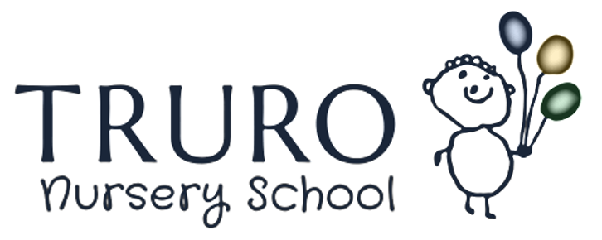

Sessions offered

We offer a morning session from 8.45am to 11.45am and an afternoon session 12.30pm to 3.30pm. Both sessions are 3 hours in length and we ask that all parents/carers are punctual in collecting and dropping off their children to avoid disruption to the other children.

Breakfast and Afterschool Sessions
Each morning there is a before school session between 8am and 8.45am, or a short early drop-off option from 8.30am to 8.45am.
Lunchtime Session
We offer a lunchtime session from 11.45am to 12.30pm. If children are attending this session they will need to bring in a packed lunch. We promote the healthy schools agenda. Our staff sit with the children to encourage and support them.
Afterschool Sessions
Every afternoon there is also an afterschool session which is open from 3.30pm – 5.30pm and a later pick-up option between 3.30pm – 3.45pm.
Holiday club
We are a school so we are open for term times only. However, in order to support families we operate a holiday club so we are open for a few days in the Christmas and Easter holidays as well as several weeks over the Summer holidays.

The above sessions are offered to the following age groups:
Our two year old provision:
We established our provision for two year olds in September 2017 having done substantial research prior to set up. We know from research that what matters with 2 year olds (as well as with the older children) is the quality of the provision. We believe that this is predominantly determined by the qualifications and experience of the staff leading the learning. This is particularly the case for supporting disadvantaged children.
At Truro Nursery School we have a number of qualified teachers and a Headteacher who lead the learning as well as several support staff who are also graduates. Altogether, this makes for a really strong and consistent team. We therefore felt that we were in a unique position in Truro to extend our very high quality provision to include younger children.
The space:
We have a dedicated space which has been completely refurbished to meet the needs of younger children. They have a range of open ended resources available to them, a changing space, a quiet comfy area for resting or sleeping and of course access to the whole Nursery including a wonderful outside space.
The group:
The number of 2 year olds that we have in any one group can very from 3 to 4 children to a maximum of 12 children.
The team:
We know that the key person is essential to a 2 year old’s development which is why our team are dedicated and wonderful people who nurture those early relationships exceedingly well.
The provision:
Most of the work we do with the children is ‘child led’ (this means that we nurture their interests and ideas). We focus on the areas of learning which are essential to further that learning e.g. speech and language development, physical development and social and emotional development.
Things we are most often asked about:
Most of our 2 year olds will be in nappies – we can work with you at the right time to help with potty training.
Some of our 2 year olds will have a sleep – this is absolutely fine and we have spaces we convert so that they can do so.
Separation – it is a very natural response for children to feel anxious when separating from parents/carers. We have years of experience of this and will help you to find the best way to help your child (and yourself!) settle.
Why not come and have a look for yourselves.

Three and four year olds
At the core of the school is the main Nursery. This provides nursery education for children aged 3 to 4. Our sessions are led by qualified teachers. Our environment is second to none children thrive with quality environments both inside and outside. We believe in childhood and allowing children to be the age that they are (not preparing to be older). Children have extended periods of time to choose and ‘wallow’ (Tina Bruce) in their play.
We ask that children join us for a minimum of 3 sessions per week (9 hours) as we know that they will thrive and learn best with extended time with us.
As children develop we provide them with increasing challenges based on their abilities to help them to develop the attributes and skills they will need for life e.g. being able to regulate their own behaviours, learning how to use tools, early literacy and mathematical knowledge and being able to communicate effectively.

